WORLD WAR II – MAP QUIZ – PRACTICE

PACIFIC THEATER

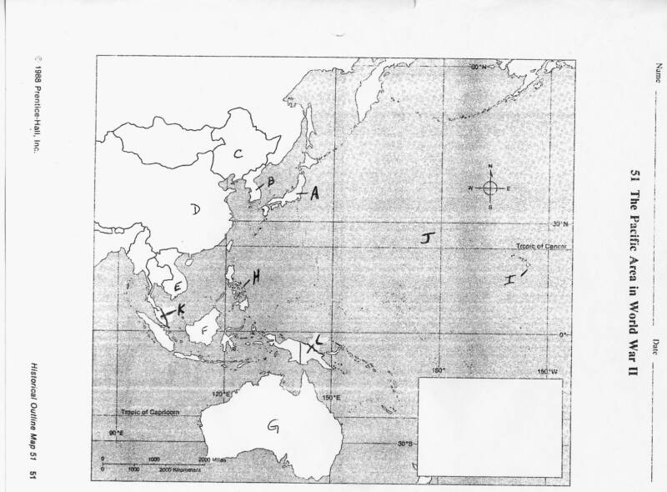
MAP IDENTIFICATION: find the country described below and place the corresponding letter from the map into the correct numbered space on the answer sheet. Some letters on the map may be used more than once & some letters may not be used at all.

1. The only country ever bombed with an Atomic bomb
2. When Japan occupied this country the U.S. cut off it's exports of oil to Japan.
3. Country to whom Gen. Douglas MacArthur promised, “I Shall Return”.
4. Japan took control of this country in 1931, set up a “puppet government” & renamed the country
“Manchukuo”.
5. The site of the first Japanese attack on the United States Pacific Fleet.
6. The U.S. wanted to preserve the “Open Door” to trade with this country.
7. Japan wanted to take this country because of its vast oil supply.
8. The battle for this island turned out to be the “turning point” in the Pacific war.
9. First country “annexed” by Japan.
10. The country where the “Bataan Death March” occurred.
EUROPEAN THEATER

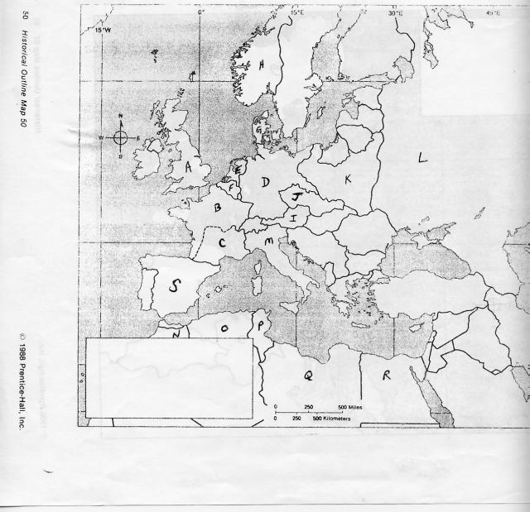
MAP IDENTIFICATION: find the country described below and place the corresponding letter from the map into the correct numbered space on the answer sheet. Some letters on the map may be used more than once & some letters may not be used at all.

11. The site of the Allied landing on “D-Day”
12. The only Western European country to successfully defend itself against Germany's invasion attempt.
13. The invasion of this country prompted France & Britain to declare war on Germany.
14. Where the “Vichy Government” cooperated with Nazi rule.
15. This country's civil war between Fascists & Socialists became a practice ground for Germany & Italy's
armies.
16. This country was the site of the “turning point” in the North African theater.
17. The western part of this country was given to Germany at the Munich Conference.
18. Country whose army was the first to enter Berlin in 1945
19. The first Fascist country in Europe.
20. Country annexed by Germany in the “Anschluss”.

