Al Qaeda’s New Front – CBC page

Go to the following site: http://www.cbc.ca/fifth/warwithoutborders/index.html

Click on “The Salafist Movement”. Read the selection.

1. According to Dr. Marc Sageman, what is the “salafi jihad”?

2. What does Dr. Mamoun Fandy, an Egyptian-born terrorism expert, say about the Salafis?

3. To whom does Fandy compare the salafist jihadist movement?

4. Name the country of origin of two of these movements of the 1920s, '30s and '40s.

5. How far did the Great Caliphate reach at it’s peak, in the 1200s?

6. When did The final remnants of the last Caliphate disappear?

7. What is meant by the "near enemy"?

8. All Islamist terrorist groups, have their roots in what organization?

9. Who is often described as the Marx or Lenin of the modern-day Salafi jihadi movement?
His American yearbook picture appears below.
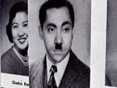

10. What did Sayyid Qutb do while in prison in the 1950’s & ‘60’s?

11. Who is the man pictured below & and what is his quote about Allah?

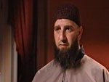

12. What is the difference between Takfir wal-Hijra Muslims and other Jihadists?

13. What is the most current manifestation of the salafi jihad movement?

