2010 - WORLD WAR II Practice Test

THE WAR IN THE PACIFIC

1. The first Naval battle in U.S. military history in which the two fleets engaged in battle but never fired a single shot at one another from their massive deck guns became known as the battle of
A. Leyte Gulf
B. Midway
C. The Coral Sea
D. Guadalcanal

2. The top-secret project carried out by U.S. scientists to develop the atomic bomb was called;
A. The Holocaust
B. Operation Torch
C. Operation Bravo
D. The Manhattan Project

3. What was the name of the battle that is considered to be the “Turning-Point” of the Pacific War?
A. Guadalcanal
B. Midway
C. Tarawa
D. Iwo Jima

4. What U.S. Navy Battleship after being sunk at Pearl Harbor was sealed by the Government and left in place
as a permanent tomb & monument to those who died at Pearl Harbor?
A. U.S.S. Nevada
B. U.S.S. Tennessee
C. U.S.S. West Virginia
D. U.S.S. Arizona

5. Which battle marked the first extensive use of deliberate “Kamikaze” attacks on U.S. warships?
A. Guadalcanal
B. Tarawa
C. Iwo Jima
D. Leyte Gulf

6. What was the name of the first Japanese city to be bombed by an atomic bomb?
- Tokyo
- Hiroshima
- Nagasaki
- Osaka

7. What was the name of the original U.S. war plan in the Pacific war?
- War Plan Orange
- War Plan Yellow
- War Plan Green
- War Plan Red

8. What was the name given to the strategy used by the U.S. forces to defeat the Japanese.
A. “Pearl’s Revenge”
B. “Island Hopping”
C. “Operation Torch”
D. “Operation Brute Force”

9. What action by the U.S. caused the Japanese to execute the Pearl Harbor attack.
A. The U.S. had sunk two Japanese destroyers in international waters.
B. The U.S. was sending supplies and equipment to rebels in Korea.
C. The U.S. cut off all oil & steel shipments to Japan until they abandoned all conquered territory.
D. U.S. forces led by General Douglas MacArthur had been secretly working for the Chinese.

10. What battle marked the U.S. Marines first big test against the Japanese?
A. Guadalcanal
B. Tarawa
C. Iwo Jima
D. Leyte Gulf

MATCHING: PEOPLE

11. Husband Kimmel A. American General in charge of the defense of the Philippines
12.Walter Short B. Japanese Admiral who planned the Pearl Harbor raid.
13. Isoroku Yamamoto C. American Admiral in charge of Pearl Harbor in 1941.
14. Douglas MacArthur D. American General in charge of Hawaii’s air bases in 1941.
15. Heideki Tojo E. Led a B25 raid on Tokyo in 1942
16. Franklin D. Roosevelt F. Chinese Communist leader
17. Jimmy Doolittle G. Minister of War in Japan
18. Mao Zedong H. President of the United States when war began
19. Chiang Kai-shek I. U.S. President who ordered the 1st use of Atomic bombs
20. Harry S. Truman J. Chinese Nationalist leader

MAP IDENTIFICATION: find the country described below and place the corresponding letter from the map into the correct numbered space on the answer sheet. Some letters on the map may be used more than once & some letters may not be used at all.

21. The only country ever bombed with an Atomic bomb
22. When Japan occupied this country the U.S. cut off it's exports of oil to Japan.
23. Country to whom Gen. Douglas MacArthur promised, “I Shall Return”.
24. Japan took control of this country in 1931, set up a “puppet government” & renamed the country “Manchukuo”.
25. The site of the first Japanese attack on the United States Pacific Fleet.
26. The U.S. wanted to preserve the “Open Door” to trade with this country.
27. Japan wanted to take this country because of its vast oil supply.
28. The battle for this island turned out to be the “turning point” in the Pacific war.
29. First country “annexed” by Japan.
30. The country where the “Bataan Death March” occurred.

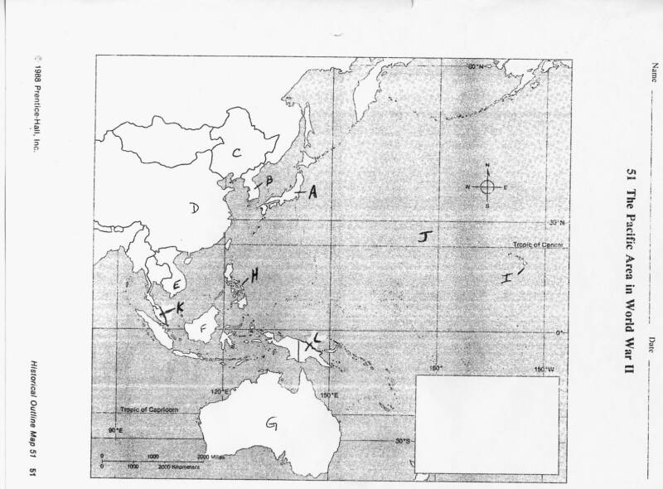

MAP IDENTIFICATION: find the country described below and place the corresponding letter from the map into the correct numbered space on the answer sheet. Some letters on the map may be used more than once & some letters may not be used at all.

21. The only country ever bombed with an Atomic bomb
22. When Japan occupied this country the U.S. cut off it's exports of oil to Japan.
23. Country to whom Gen. Douglas MacArthur promised, “I Shall Return”.
24. Japan took control of this country in 1931, set up a “puppet government” & renamed the country “Manchukuo”.
25. The site of the first Japanese attack on the United States Pacific Fleet.
26. The U.S. wanted to preserve the “Open Door” to trade with this country.
27. Japan wanted to take this country because of its vast oil supply.
28. The battle for this island turned out to be the “turning point” in the Pacific war.
29. First country “annexed” by Japan.
30. The country where the “Bataan Death March” occurred.

THE WAR IN EUROPE

31. Which of the axis powers was the first to attack a neighboring country?
A. Germany
B. Japan
C. Italy
D. Denmark

32. What was the name of the first country annexed by Germany?
A. Austria
B. Czechoslovakia
C. Poland
D. France

33. What country had a civil war between fascists & socialists in 1936, and became the site where Germany & Italy could test their newest weapons and tactics of war?
A. Greece
B. Bulgaria
C. Portugal
D. Spain

34. Hitler’s attempt to annihilate all of Europe’s Jews is know as;
A. The Anschluss
B. The Holocaust
C. The New Crusade
D. The Thousand-year Reich

35. In an attempt to satisfy Hitler’s desire to rebuild Germany, the British and French agreed to give in to Hitler’s demands and give Germany the “The Sudatenland” in the western part of Czechoslovakia.
This policy of giving in became known as;
A. “Cowardice”
B. “Appeasement”
C. “Anschluss”
D. “Mollification”

36. Instead of a military occupation of all of France, Hitler allowed some French government officials to operate a “puppet government” run by officials who would collaborate with the Nazi’s. This government was allowed to “rule” the south-eastern part of France. It became known as the ____ Government.
A. Vichy
B. Shadow
C. Traitorous
D. Normandy

37. Germany’s generals devised a new type of warfare which relied on fast movement and coordinated air and ground attacks. This new type of warfare was called;
A. Wermacht
B. Luftwaffe
C. Blitzkrieg
D. Panzermachen

38. Which of the following was NOT one of the “Axis Powers”.
A. Germany
B. Italy
C. Japan
D. China
39. What does "Lebensraum" mean?

A. "Leadership"
B. "Living Space"
C. "Superiority"
D. "Cleansing"

40. After Hitler’s armies marched into this country, Britain & France finally declared war on Germany.
A. Poland
B. Belgium
C. Holland
D. Denmark

41. What country signed a secret agreement with Germany stating that their two countries would not attack each other & would share in a division of Poland.
A. Austria
B. Hungary
C. The USSR
D. Rumania

42. After conquering Poland in less than a month, German troops stopped to regroup and resupply their armies. The French were reluctant to attack the German’s “Siegfried Line” of defenses. As a result there was very little fighting done in the winter of 1939-40. In the United States this period was known as;
A. “The short-lived peace”
B. “The Great Pause”
C. “The Phony War”
D. “The Non-War”

43. The General who was so successful in North Africa that he became known as the “Desert Fox” was;
A. Irwin Rommel
B. George S. Patton
C. Hienz Guderian
D. Bernard Montgomery

44. Which of the following countries was NOT represented at the Munich Conference?
A. Italy
B. Czechoslovakia
C. Britain
D. Germany

45. Hitler’s attempt to “bring Britain to her knees” through a program of massive bombings of British cities including
London & Coventry became known in Britain as;
A. “Hell-fire”
B. The Blitz
C. “The Lightning Raids”
D. “The Great Trial”

46. In August of 1941 Franklin D. Roosevelt & Winston Churchill met in a battle-camoflaged warship off the coast of
Newfoundland to set out the Allied war aims, even before the U.S. had joined the war. This statement of war aims is known as
A. the Atlantic Charter
B. the Newfoundland Plan
C. the New World Order
D. the New Freedom

47. How did Hitler rise to power in Germany?
A. He orchestrated a coup that overthrew the municipal government in Munich, giving him administrative power
B. He led an army junta
C. He was appointed Chancellor by the president and asked to form a government
D. None of the Above

48. What was the name of the battle that is considered to be the “Turning-Point” of the war in North Africa?
A. El Alamein
B. Kasserine Pass
C. Tunis
D. Alexandria

49. What was the name of the battle that is considered to be the “Turning-Point” of the war in Eastern Europe?
A. Stalingrad
B. Kiev
C. Moscow
D. Minsk

50. The Allied plan for the invasion of Europe was code-named
A. Operation Torch
B. Operation Barbarossa
C. Operation Overlord
D. Operation Market Garden

51. After the Allied victory in North Africa, Churchill urged the Americans to strike at the “soft under-belly of the Axis”.
Where did the U.S. decide to attack?
A. Greece
B. The south coast of France.
C. Albania
D. Sicily

52. Which was the first of the Axis Powers to surrender to the Allies?
A. Italy
B. Germany
C. Japan
D. Bulgaria

53. Which of the following was NOT part of the Nuremberg Laws?
A. Jews had to wear a yellow star to identify them
B. Jews could not marry non-Jews
C. Synagogues were turned over to the State
D. Jews were deprived of citizenship rights

54. What was the "phony war"?
A. A six month period after the fall of Poland during which no military action was taken
B. A period of a few weeks during which Germany crushed the Low Countries
C. Most of 1939-1940, when German successes were so astounding that people did not even consider this to be a real war
D. The period between the Non-Aggression Pact and the German invasion of Russia, when Russia and Germany were in
an odd state of peace.

55. From December 1944-January 1945 Germany fought an all-out attempt to break through the Allied lines with a
surprise thrust through the Ardennes Forest. This month-long battle was known as the battle of
A. Desperation
B. Belgium
C. the Bulge
D. the Panzers

56. What was the main goal of Hitler's signing of the Non-Aggression Pact?
A. To create an offensive alliance with the Soviet Union
B. To solidify his alliance with Italy
C. To delay the possibility that Germany would have to fight a two-front war
D. To make peace with the United States, a power he did not want in the war
57. What was the goal of the Kellogg-Briand Pact?
A. To outlaw war as a tool of foreign policy
B. To unite the United States and France against Germany
C. To create the United Nations
D. To support the policy of appeasement

58. Which of the following was not a stated goal of Hitler's Nazi regime?
A. Gaining colonies for the German Empire
B. Lebensraum
C. Rearmament
D. Economic recovery

59. Which country lost the greatest number of Jews?
A. Poland
B. France
C. Soviet Union
D. Germany

60. What did Japan hope to accomplish by calling its Asian Empire the Co-Prosperity Sphere?
A. Japan was dedicated to economic prosperity in Asia
B. Japan hoped to gain western support
C. Japan hoped to win over anti-imperialist sentiment
D. None of the Above

61. Which of the following groups did not send troops to the D-Day invasion?
A. Canada
B. Free French
C. New Zealand
D. Switzerland

62. Who led German and British forces at the Battle of El Alamein?
A. Hermann Goring and Bernard Montgomery
B. Erwin Rommel and Bernard Montgomery
C. Erwin Rommel and George S. Patton
D. Gyorgi Zhukov and Dwight Eisenhower

63. Which of the following did Japan NOT conquer?
A. Philippines
B. Guam
C. Australia
D. Singapore

64. At the Nuremberg Trials, the international community tried men accused of
A. "prosecuting an illegal war."
B. "crimes against humanity."
C. "not following orders."
D. "violating the peace and security of the world."

MATCHING: PEOPLE

65. Charles DeGualle A. USSR leader who signed a non-aggression pact with Hitler
66. Winston Churchill B. British Prime Minister in World War II
67. Joseph Stalin C. Tank Commander known as the “Desert Fox”
68. Adolf Hitler D. the founder of Fascism & Italy's wartime leader
69. Benito Mussolini E. Wrote Mein Kampf while in prison
70. Irwin Rommel F. Leader of the “Free French” forces

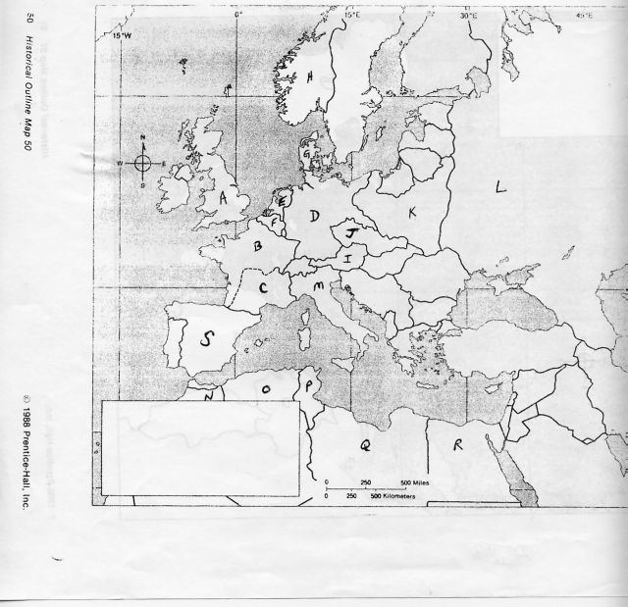

MAP IDENTIFICATION: find the country described below and place the corresponding letter from the map into the correct numbered space on the answer sheet. Some letters on the map may be used more than once & some letters may not be used at all.

71. The site of the Allied landing on “D-Day”
72. The only Western European country to successfully defend itself against Germany's invasion attempt.
73. The invasion of this country prompted France & Britain to declare war on Germany.
74. Where the “Vichy Government” cooperated with Nazi rule.
75. This country's civil war between Fascists & Socialists became a practice ground for Germany & Italy's armies.
76. This country was the site of the “turning point” in the North African theater.
77. The western part of this country was given to Germany at the Munich Conference.
78. Country whose army was the first to enter Berlin in 1945
79. The first Fascist country in Europe.
80. Country annexed by Germany in the “Anschluss”.

